<https://wordwall.net/resource/67068594/>

Next to the game, you will find a sub-menu on the right, to switch the game template:

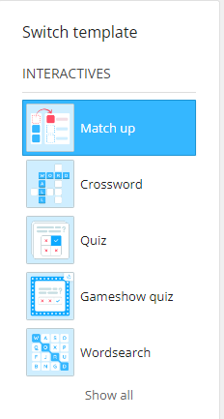Try some of the other games too which will enable more practice.

Signed:.................................................

Date:.....................................................