<https://wordwall.net/resource/24855159/french-quantities>

<https://wordwall.net/resource/243846/french/la-nourriture-quantities>

Next to the games, you will find a sub-menu on the right, to switch the game template:

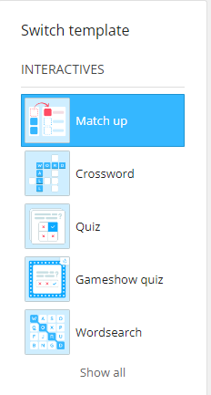Try some of the other games too which will enable more practice.

Signed: ...................................... Date: .................................